OUTHOUSE CHALLENGE
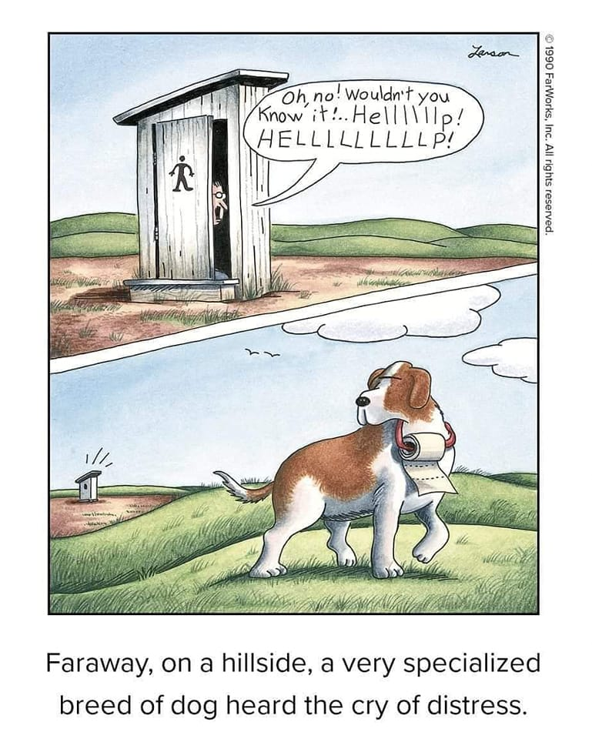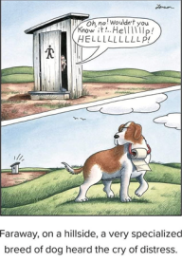
AT ST. AUGUSTINE'S
May 2023
The Baldwinsville Food Pantry
Needs Our Help!!!
Did you know that food stamps do not cover
paper products and toiletries?
Faraway on a hillside, a very specialized breed of dog, a “St. Augustine” named Bruno, heard the cry of distress……..

Historically, St. Augustine's response to this project has provided the food pantry with enough supplies to cover their needs for several months. Requests for assistance remain high. Without our help, the food pantry must purchase these items. Please drop your donations in the outhouse located in the Gathering Space.

SUGGESTED ITEMS
Toilet paper | Toothbrushes
Paper towels | Toothpaste
Tissues | Dental floss
Laundry soap | Mouthwash
Fabric softener | Deodorant
Dryer sheets | Shampoo
Toilet bowl cleaner | Conditioner
Disinfectant wipes | Liquid hand soap
Disinfectant spray | Bar soap
Dish soap | Body wash
Lotion

